**Introduction to the feasibility analysis of the GoSafe :-**

The preliminary objective of the feasibility analysis is verify is the GoSafe is a sustainable in the world or not. A system is feasible or not is dependent on the amount of resources that are required and will be used. So we focused on following aspects to check whether the project (GoSafe):-

1. **Technical Feasibility :-**

This is a web based project. So the technical thing/resources are the main server and database to store every action. Since these days there are many online websites that provide webhosting for free and also give some amount of database to store.

1. **Operation Feasibility :-**

We are making sure that there be less traffic congestion, so that user or administration does not have any trouble. There will be no disappointment from any side. All the customer needs a web browser that supports the system requirement.

1. **Economical Feasibility :-**

The economical feasibility is an important one as how much finance we put to make the server, database and many more to work in order. But as we will be using a free server hosting service over a year, if still then also the customers are in need for this we make it a permanent service.

1. **Behavioral Feasibility :-**

We have mainly focused on the friendly User Interface. The user can use it without any experience. We have also provided an online help for any need for the customer as well as for the administration.

1. **People’s opinion, their suggestion and their commitment to use the website. :-**

`Our group has taken a survey; asking some people to fill the form for some question regarding the project GoSafe.

From below charts; we can see that many people are having trouble finding the mobile numbers and contacting the Cab Companies, so we are taking that time out from both the user and manager of that company. The GoSafe’s main feature is the cab sharing and the many people are interested in this feature. Some comments by the people are, making a APP, and wanted to make a connection with the Moodle of a University so that they from there it can redirect to our website and many more.

Here I have added some pie charts of responses that we got from people:-

1. Responses for question 1 :-

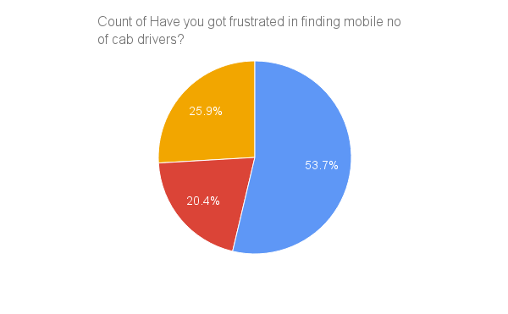

1. Responses for question 2 :-

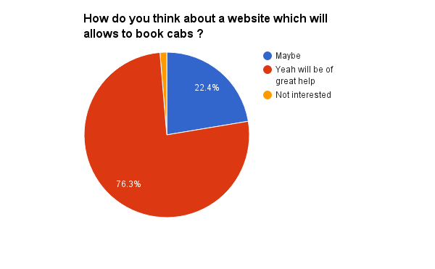

1. Responses for question 3 :-

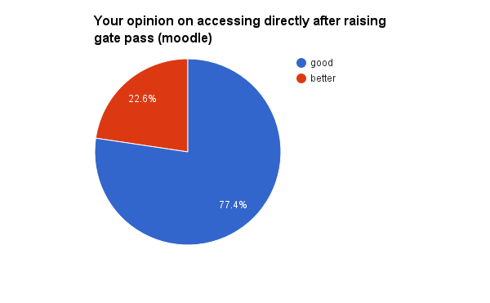

1. Responses for question 4 :-

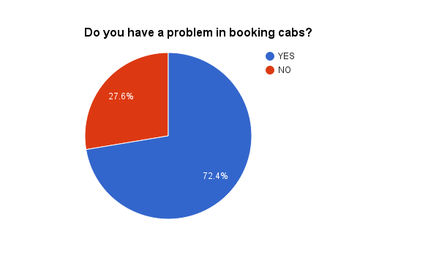

1. Responses for question 5 :-

